Improving the Divide-and-Conquer Approach to Sum-of-Pairs Multiple Sequence Alignment
J. Stoye, S. W. Perrey, and A. W. M. Dress
Applied Mathematics Letters, Volume: 10, Issue: 2, March, 1997, pp. 67-73
- Introduction
- The Basic Algorithm
The weighted sum of pairs multiple sequence alignment problem
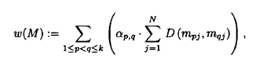
The resulting score matrices for pairwise alignment give rise to additional cost matrices
Here uses a weighted sum of additional cost over all projections(c_{p}, c_{q}) as such an estimate
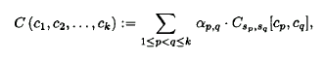
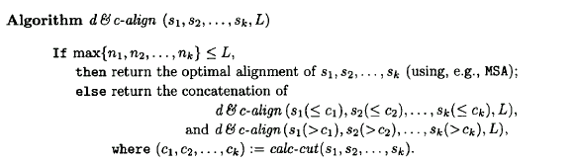
Time = O(k²n² + n ^{k-1});
Space= O(k²n²⁾

- Efficiently Calculating the Slicing Sites
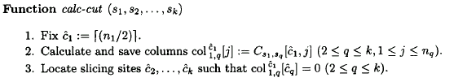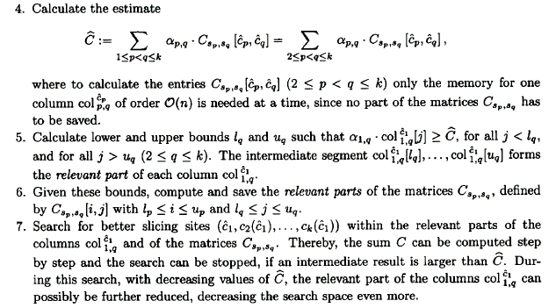

Time = O(k²n² + r ^{k-1});
Space = O(kn + k²r²); r= max_{p=2,…k}{u_{p} – l_{p} +1}
Worse case Time = O(k²n² + n ^{k-1});
- Results
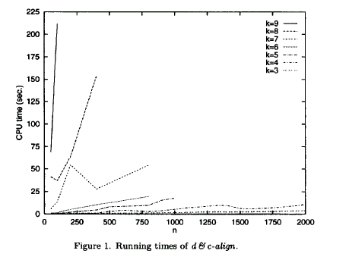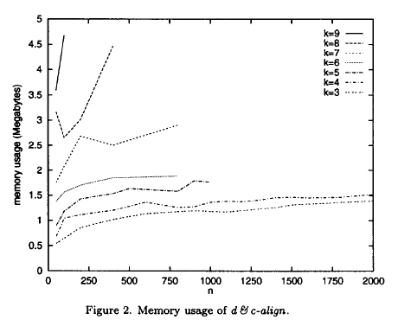

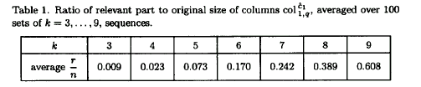

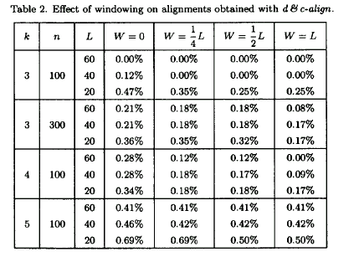
Created by: Ming-Cheng Lin
Date: June 7, 2000

